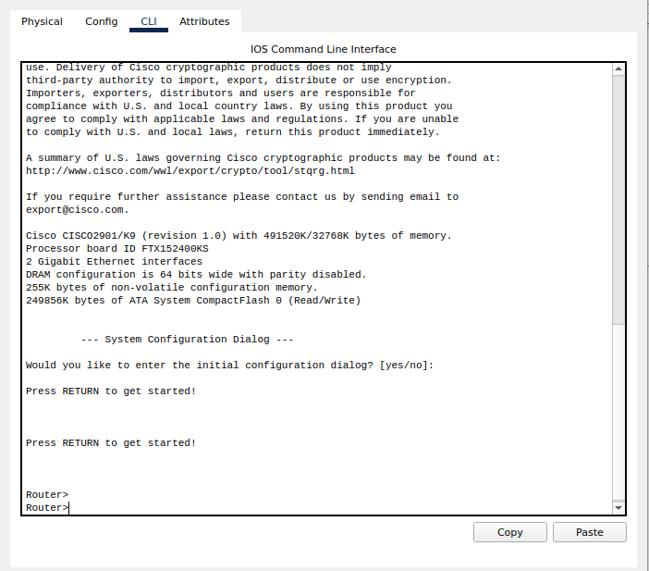

Mode 2: Privileged EXEC Mode
The Privileged EXEC Mode is represented by ‘Router #’ .
To enter this mode, we have to write ‘enable’ in the Command Line Interface.
Demonstration:
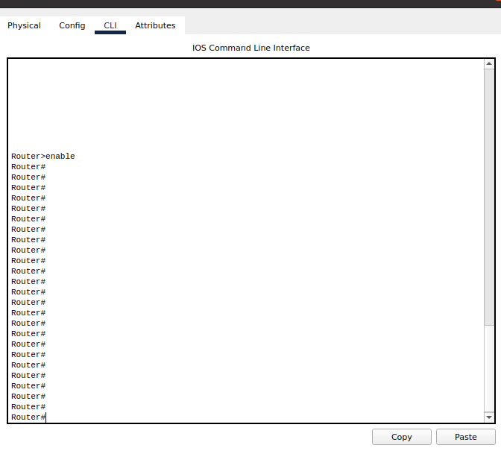
Mode 3: Global Configuration Mode
The global configuration mode is represented by ‘Router(config)#’.
To enter ‘router configuration mode’, we have to write ‘configure terminal’ in the CLI.
Demonstration:
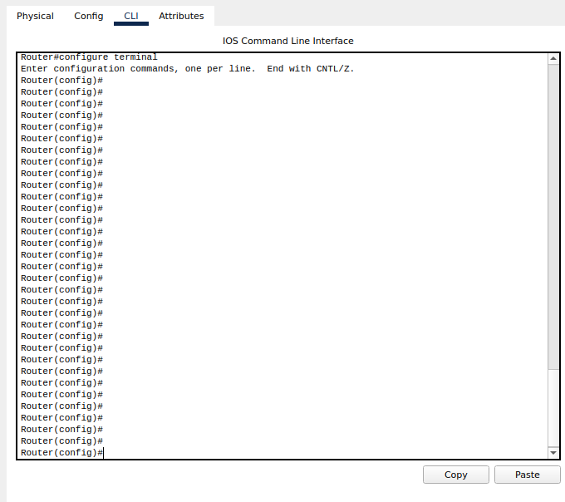
Mode 4: Interface Configuration
The interface configuration mode is represented by ‘Router(config-if)#’.
To enter ‘Interface Configuration’ mode, we have to write ‘interface <interface
name+number>’ in the CLI.
Exiting Mode:
To exit any mode. Simply type the word ‘exit’ in the CLI.
Demonstration:
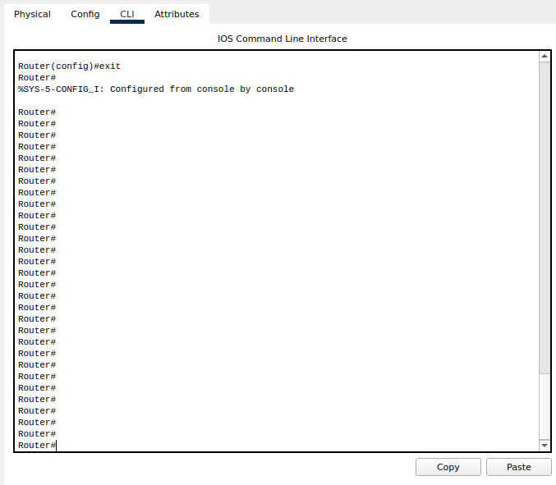
HOST Name:
Changing Host Name:
The Host Name of the router can also be changed.
To change the host name of a router, the ‘HOSTNAME ’ command is used in the CLI.
To change the host name, first of all you have to change the mode of the router.
Chain Of Command:
To change the host name of a router. Enter the following commands in order.
Command 1: Router> enable
Command 2: Router#configure terminal
Command 3: Router(config)#hostname NP
Command 4: Router(config)# exit
Command 5: NP#
Demonstration:
Command 1:
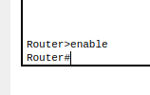
Command 2:
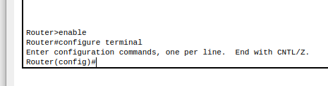
Command 3:
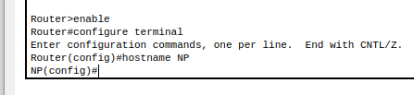
Command 4:
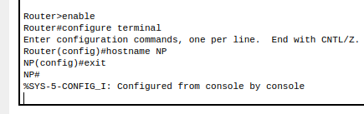
Command 5:
Command 5 is actually the demonstration of the final product ‘NP’
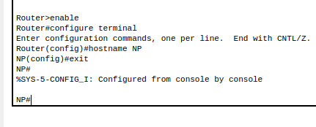
Date And Time:
Configuring Date And Time Of Router:
The Date And Time of the router can also be changed.
This whole process is done via the Commands in the CLI.
Chain Of Commands:
In order to change the Date and Time of the router, use the following chain of commands in the particular order.
Command 1: clock set?
Command 2: clock set 12:15:00 ?
Command 3: clock set 12:15:00 17 ?
Command 4: clock set 12:15:00 17 March 2021
Command 5: For Verification, use command ‘show clock’
Demonstration:
Command 1:
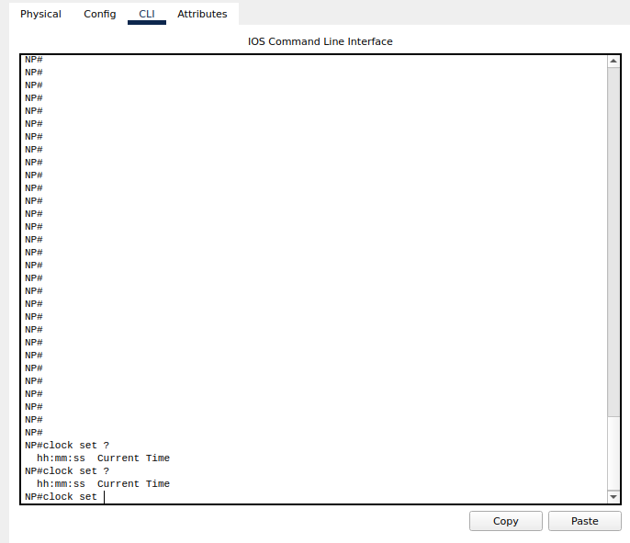
Command 2:
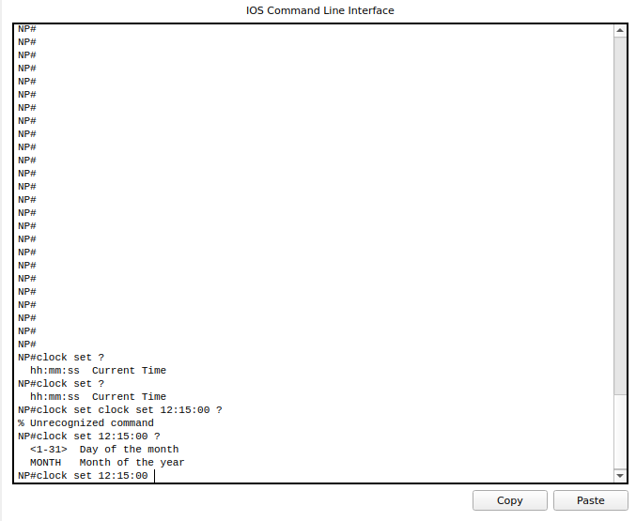
Command 3:
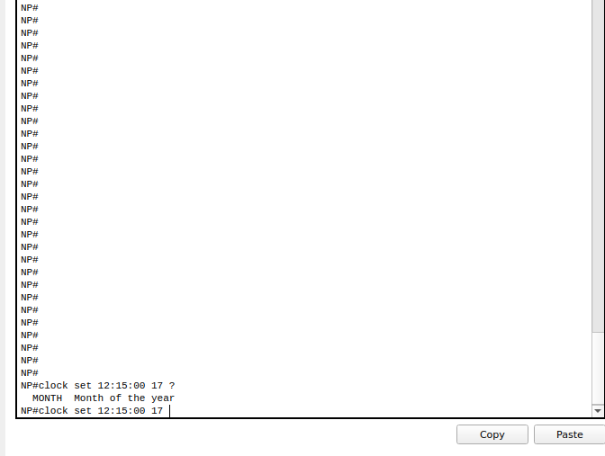
Command 4:
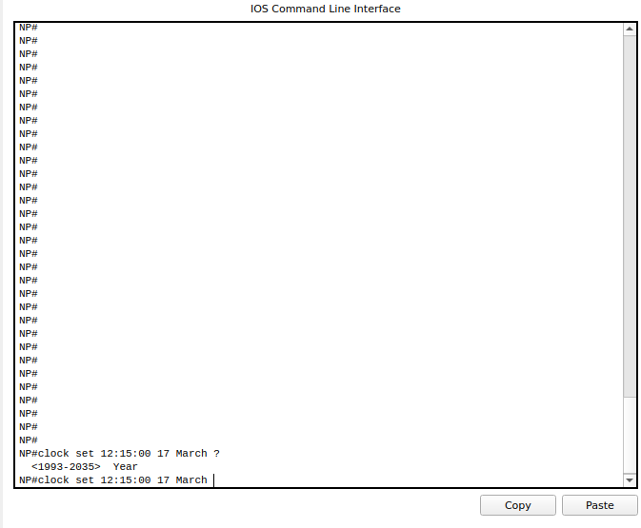
Command 5:
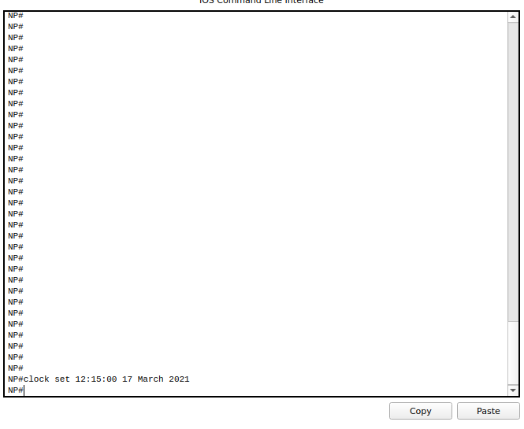
Command 6:
For verification, use this command.
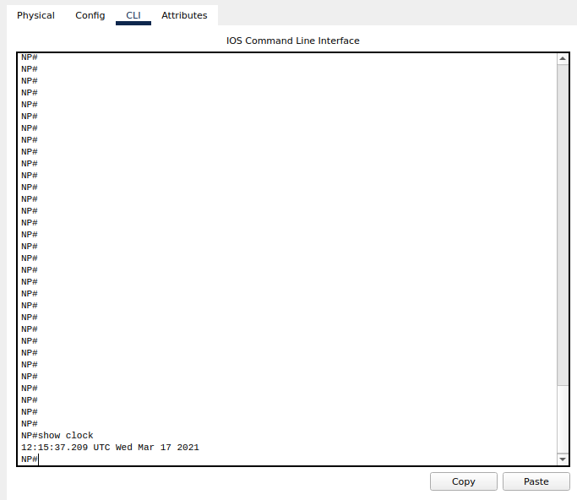
Banner of Router:
When someone connects to the router, a pop-up show up. This pop-up is called as the banner.
Setting Banner Of The Router:
We can also set the Banner for our Router.
This banner can be configured for the router by using the Command Line (CLI).
Chain Of Commands:
To set the banner for a router, use the following chain of commands in the order.
Command 1: enable
Command 2: configure terminal
Command 3: banner motd # welcome to Networks Professionals #
Command 4: exit
Command 5: exit
Demonstration:
Command 1:
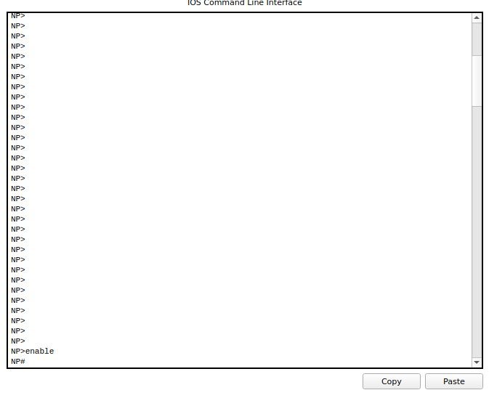
Command 2:
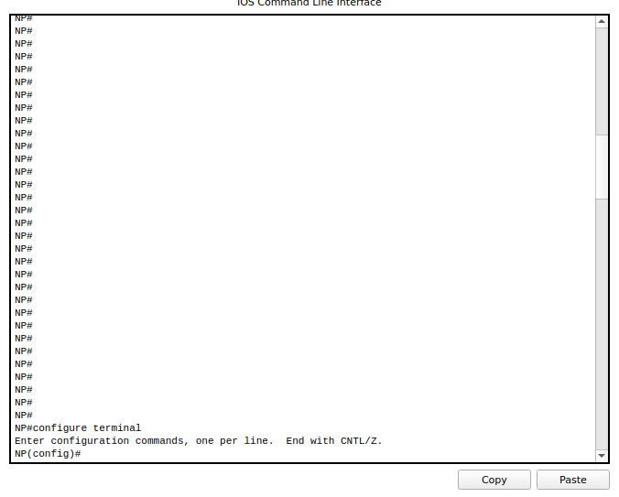
Command 3:
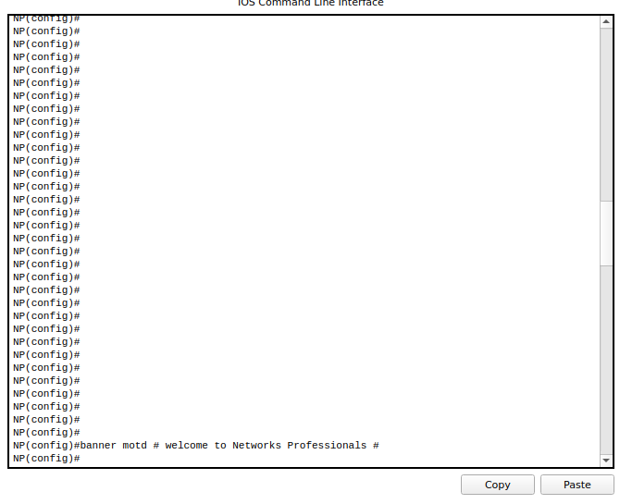
Command 4:
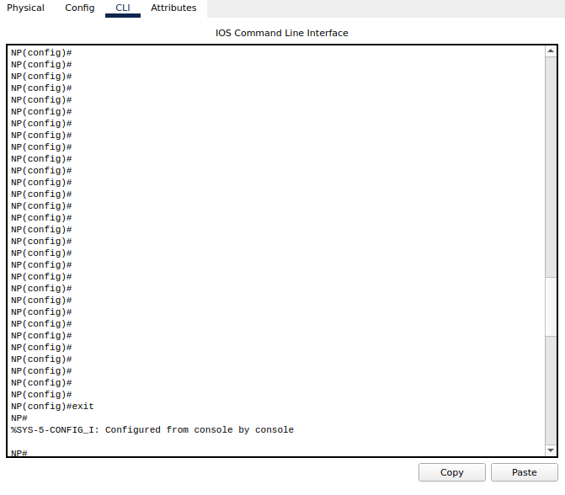
Command 5:
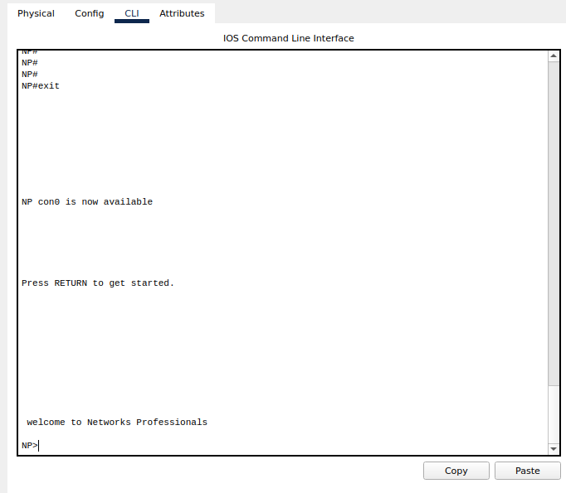
Running Configurations And Startup Configurations Of The Router:
Displaying Running Configurations And Startup Configurations Of The Router:
We can also display the running and startup configurations of the router by using the CLI.
Chain Of Commands:
Use the following chain of commands in order to display the startup and running configurations of the router.
Command 1: enable
Command 2: show running-config
Demonstration:
Command 1:
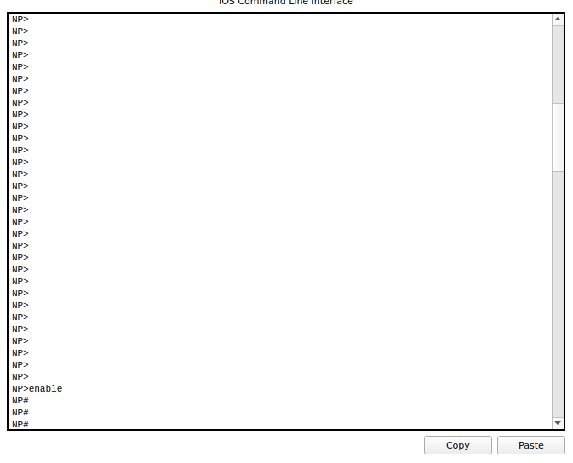
Command 2:
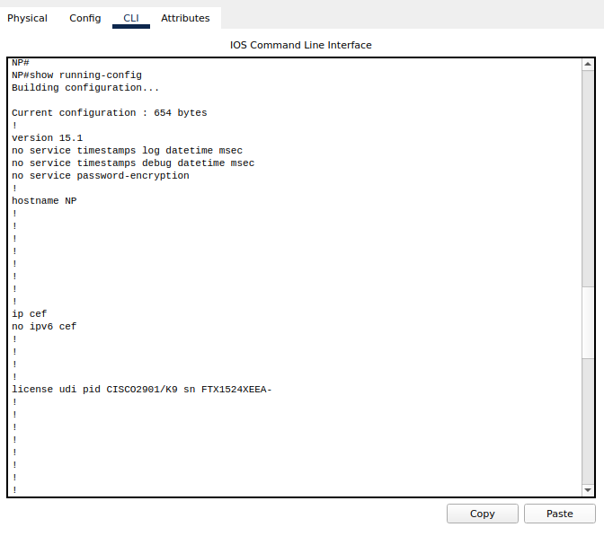
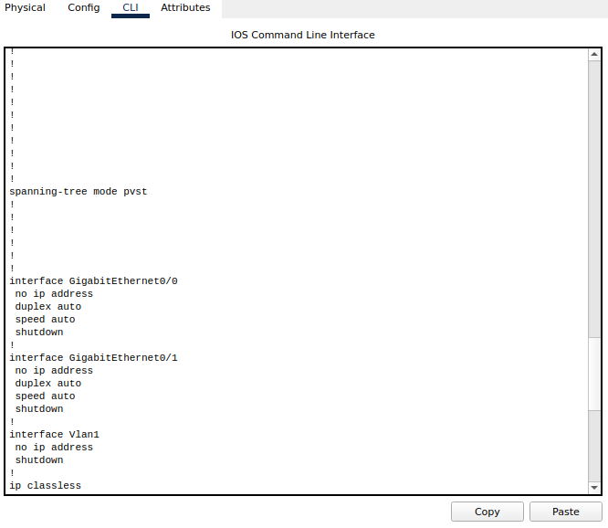
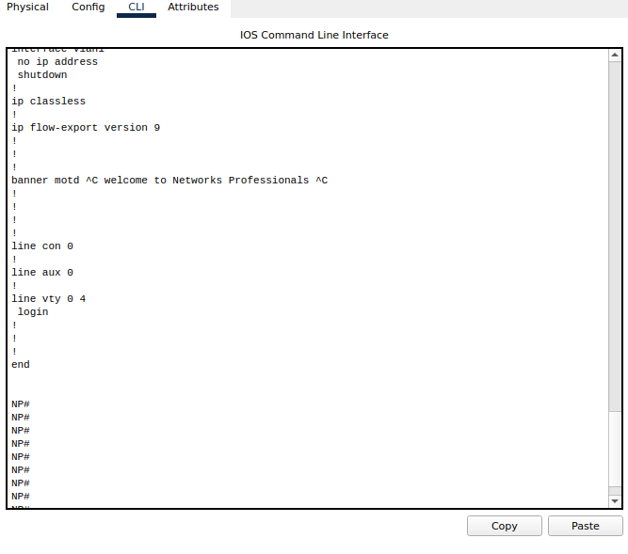
Password and Enable Secret Password with the Encryption Techniques/Levels:
Enabling Password and Enable Secret Password with the Encryption Techniques/Levels:
We can also set Password and Secret Password for our router.
Chain Of Command:
Use the following chain of command to set the Password and Secret Password for the router.
Starting Command: enable
Command 1: configure terminal
Command 2: enable password NP222
Command 3: exit
Command 4: enable
Message: Enter Password
Demonstration:
Starting Command:
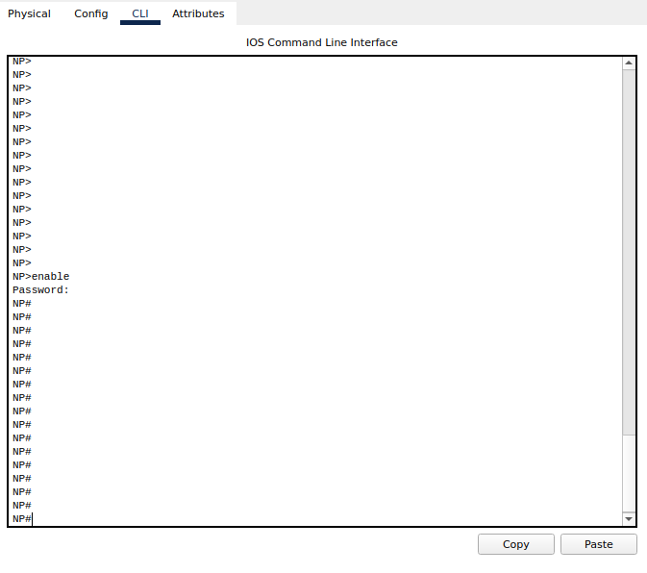
Command 1:
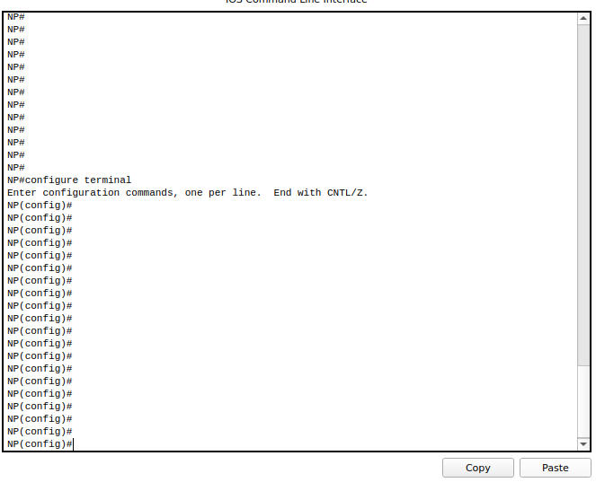
Command 2:
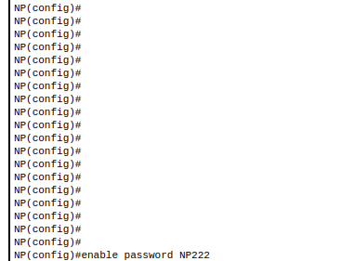
Command 3:
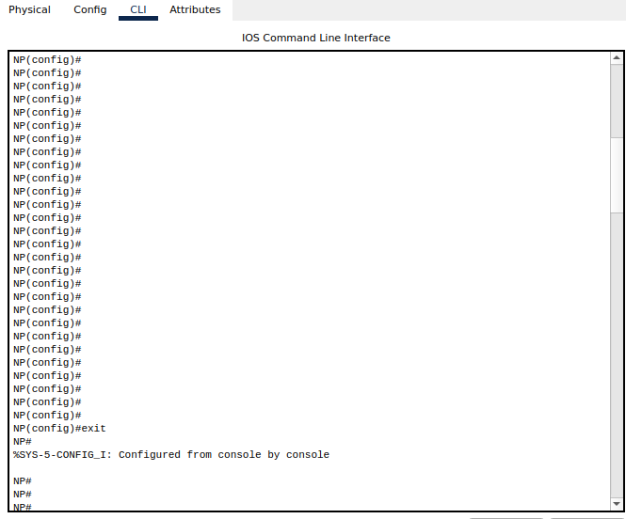
Command 4:
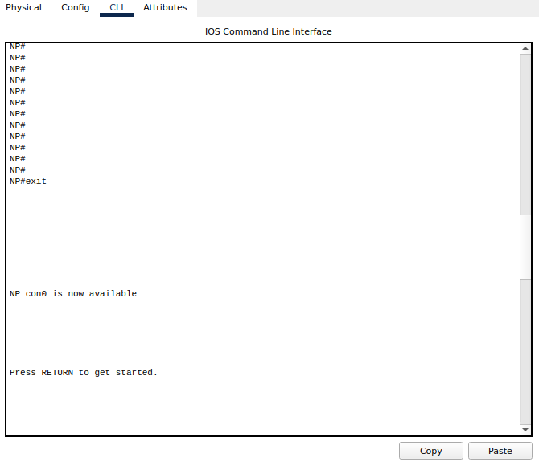
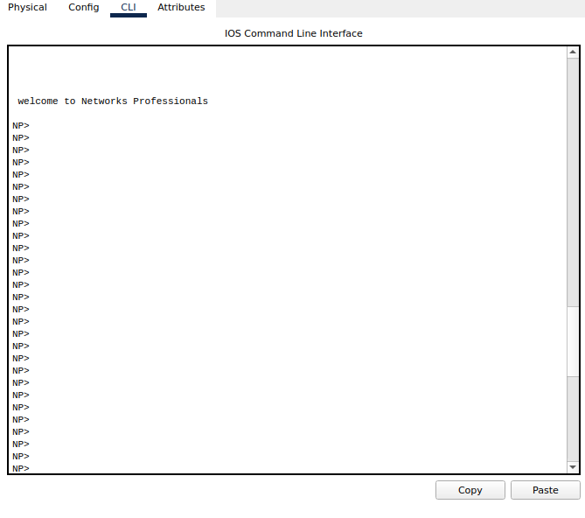
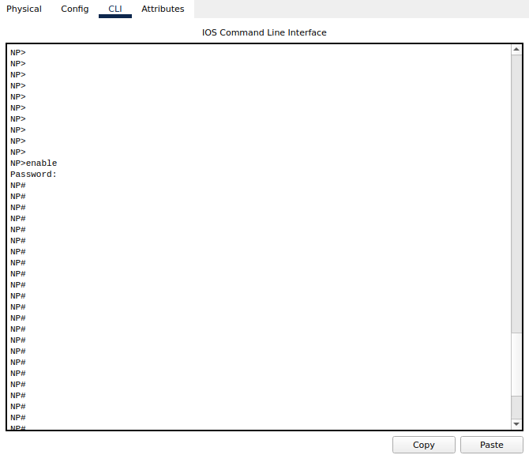
Secret Password For Privileged Mode:
You can also set a secret password for a router.
Chain Of Commands:
Use the following chain of commands.
Command 1: enable
Command 2: configure terminal
Command 3: enable ?
Command 4: enable secret NP333
Command 5: exit
Demonstration:
Command 1:
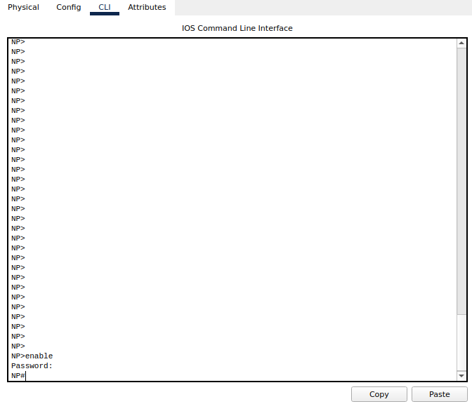
Command 2:
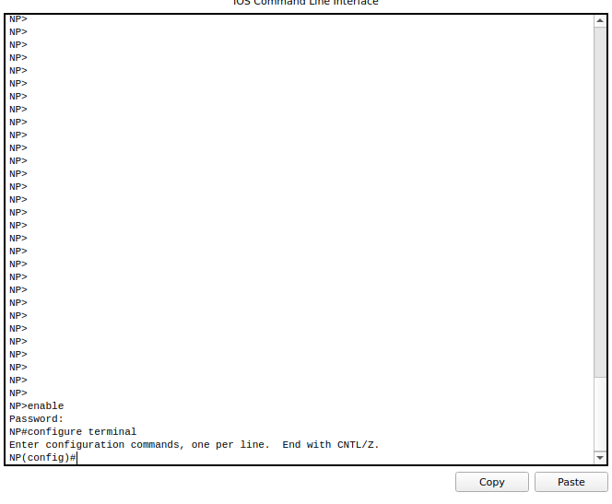
Command 3:
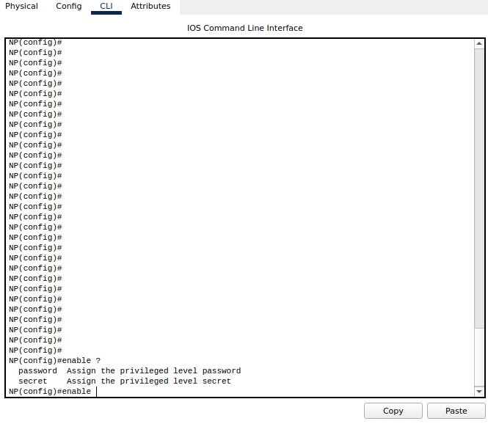

Command 4:
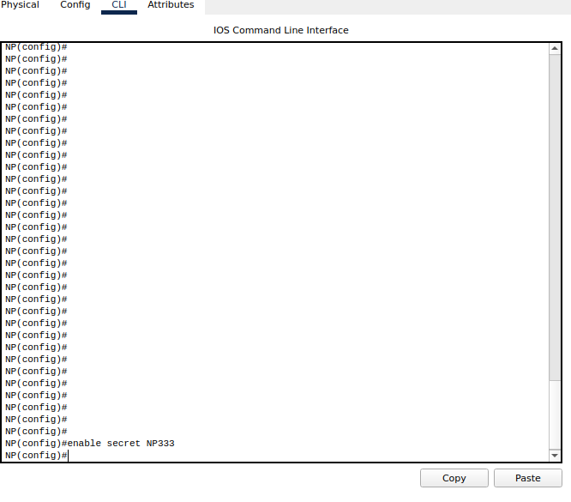
Command 5:
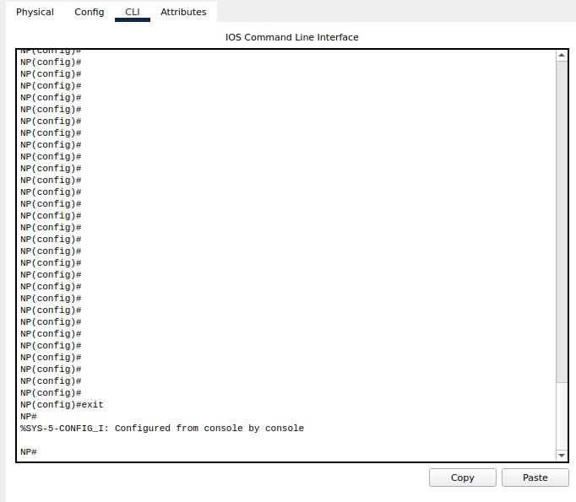
Verification:
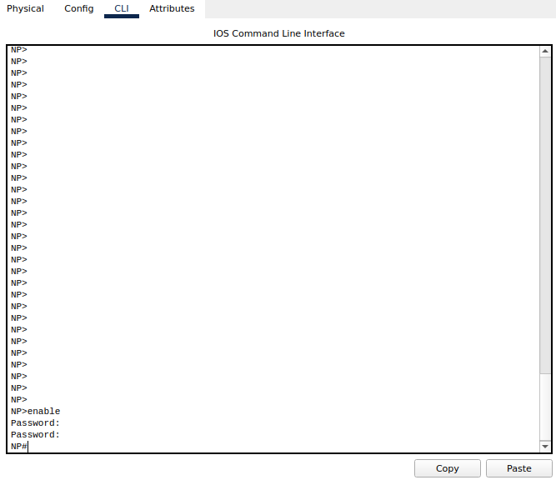
Line Console Password:
You can also set the Line Console Password for a router.
Chain Of Commands:
Enter the following commands in order.
Command 1: enable
Command 2: configure terminal
Command 3: line console 0
Command 4: password NP123
Command 5: login
Command 6: end
Demonstration:
Command 1:
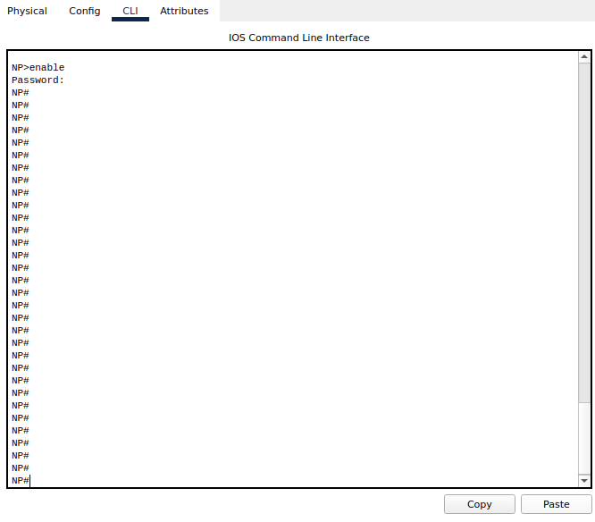
Command 2:
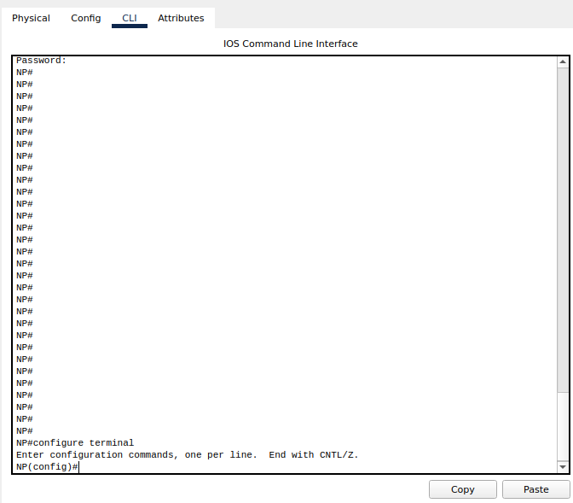
Command 3:
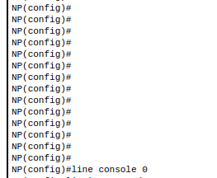
Command 4:
Command 5:
Command 6:

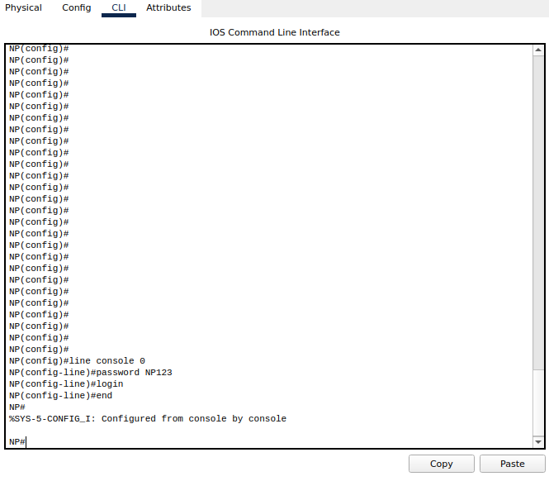
Telnet:
What is Telnet?
Answer:
Telnet is a network protocol used to virtually access a computer and to provide a two-way, collaborative and text-based communication channel between two machines. It follows a user command Transmission Control Protocol/Internet Protocol (TCP/IP) networking protocol for creating remote sessions.
Telnet is a text-based program that lets you access the console on a router or other device and issue commands. You can Telnet into a router using the Telnet client included with Windows. ... Unlike other protocols, Telnet isn't secure and shouldn't be used over the Internet.
How to Telnet?
Answer: Typing telnet hostname would connect a user to a hostname named hostname. Telnet enables a user to manage an account or device remotely. For example, a user may telnet into a computer that hosts their website to manage his or her files remotely. ... As shown, a telnet session is a command line interface.
Line VTY/Telnet Password:
Use the following chain of command to for Line VTY/Telnet Password.
Command 1: enable
Command 2: configure terminal
Command 3: line vty 0 4
Command 4: password NP456
Command 5: login
Command 6: exit
Command 7: exit
Demonstration:
Command 1:
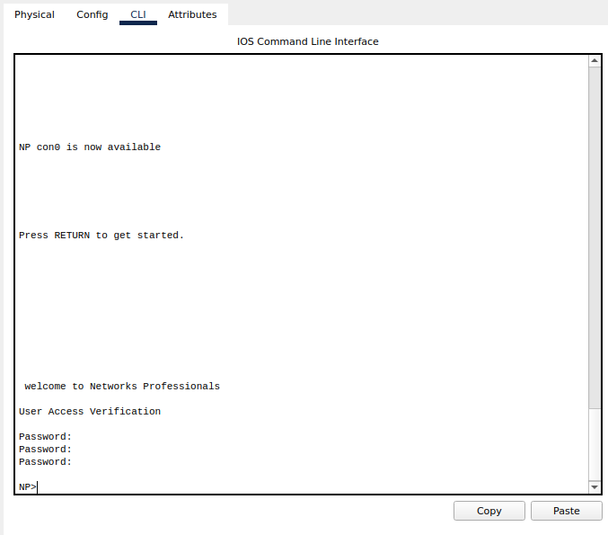
Command 2:
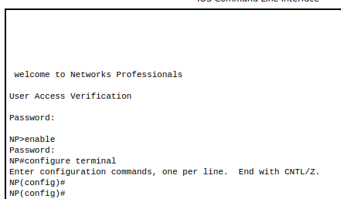
Command 3:
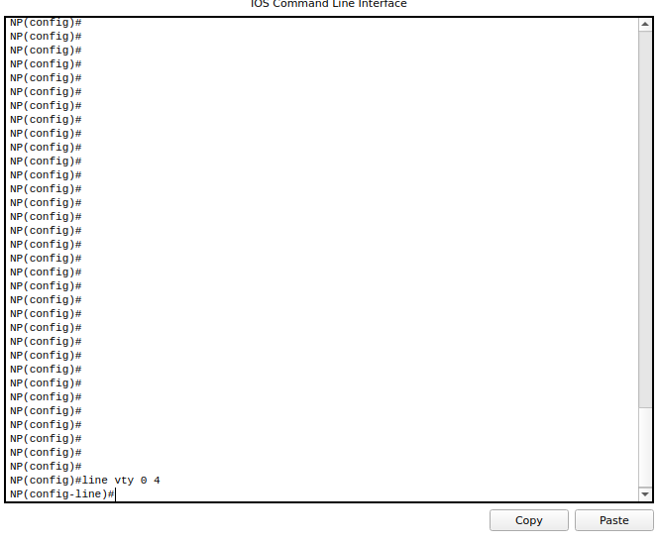
Command 4:
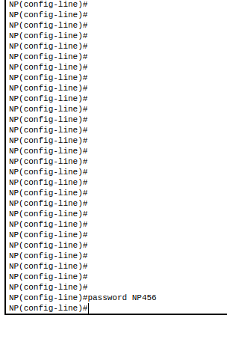
Command 5:
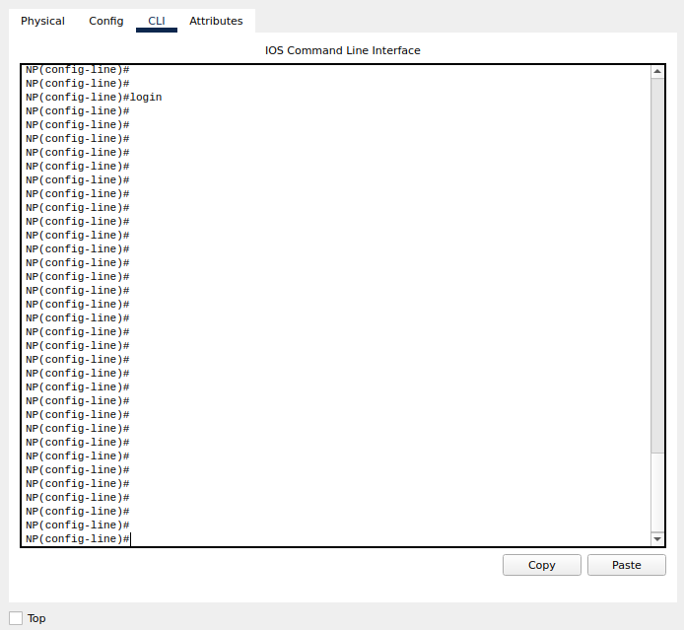

Command 6:
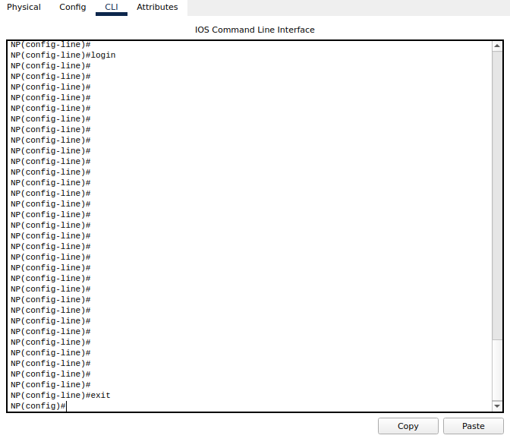
Command 7:
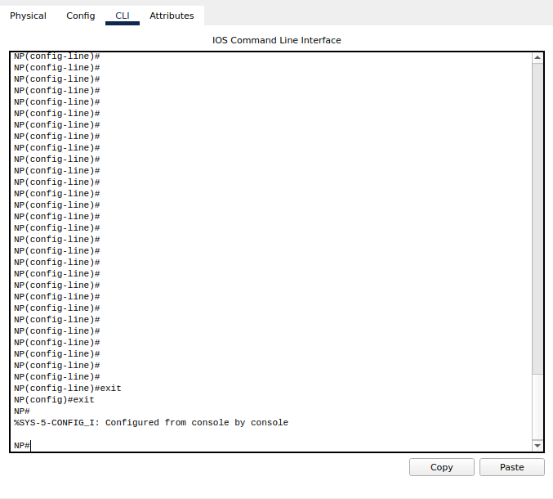
Auxiliary Line Password:
You can also auxiliary line password on your router.
Chain Of Commands:
Use the following chain of commands.
Command 1: configure terminal
Command 2: line aux 0
Command 3: password NP@786
Command 4: exit
Command 5: login
Command 6: exit
Demonstration:
Command 1:
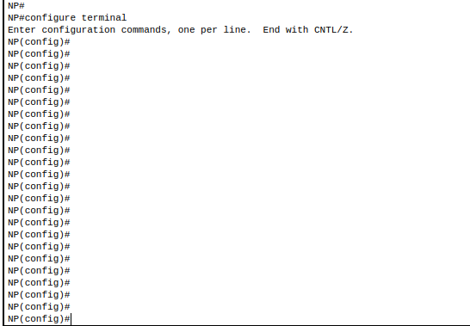
Command 2:
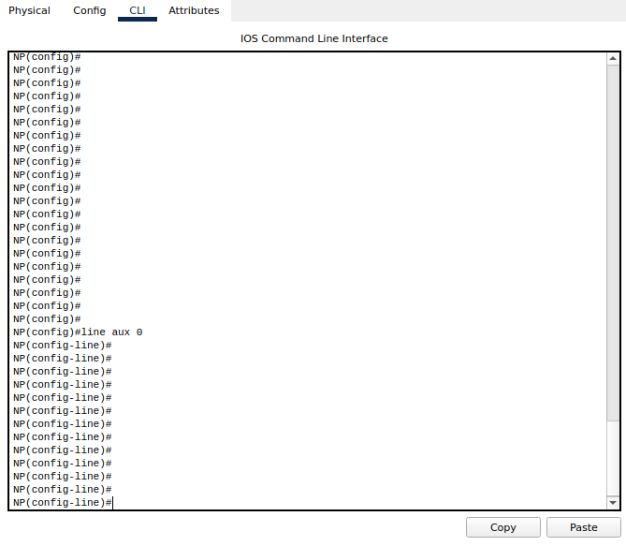
Command 3:
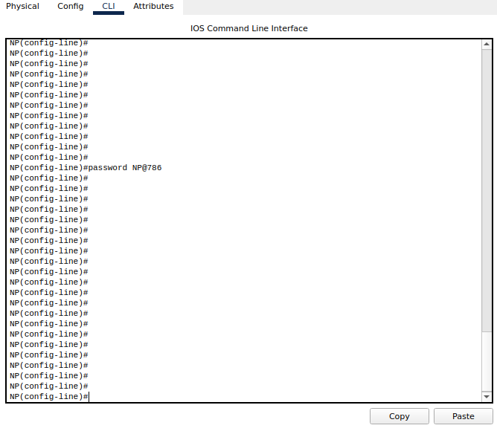
Command 4:
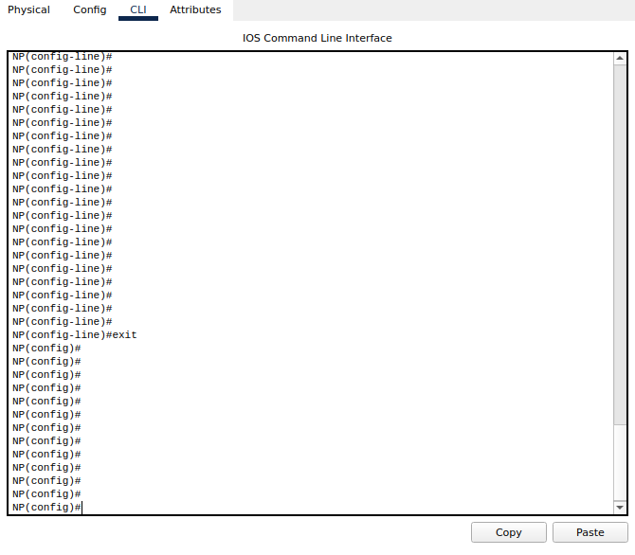
Command 5:
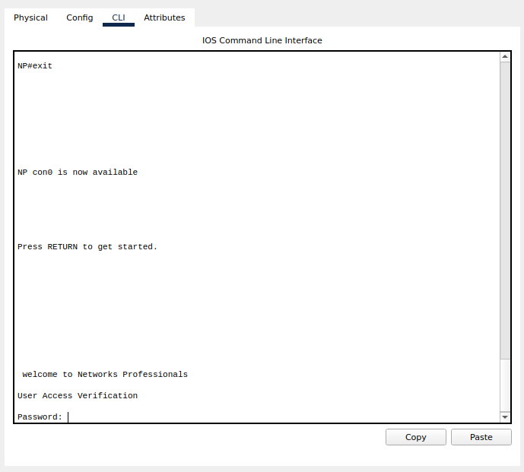
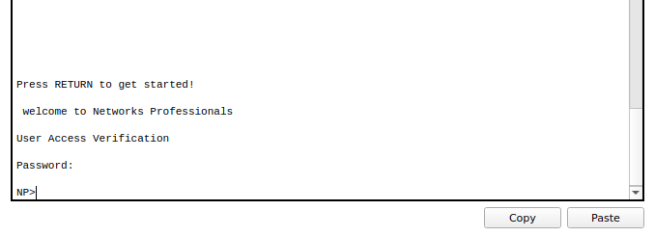
Usage Of Routers With Different Topology:
Following are the few uses of Routers in different Networks in different topologies.
- RPL Routing in Smart Object Networks
- Global and detailed routing

- Distributed Information Resources
- Exchange Transport and Routing
- Spark and dask performance analysis based on ARL image library
- Synthesis of clock and power/ground networks
- Managing the Hub Transport Server Role
- Routing Protocols
- Cloud Access and Cloud Interconnection Networks
- Cloud Computing
Cyber Security
Network Testing
- Stress Testing
- Denial Of Services Attacks
These were the few topologies where Routers are widely used.
Few Self-Created Router Topologies:
Topology 1:
Using two routers with two different IP’s and maintaining a connection b/w four computers.
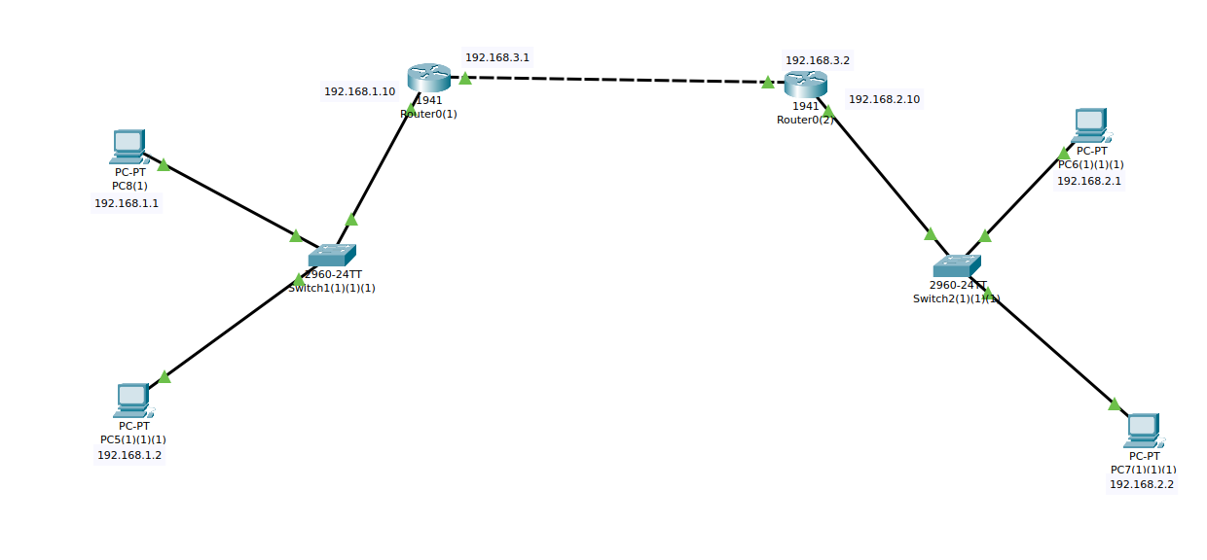
Topology 2:
Connecting three routers and establishing a connection between 6 computers.
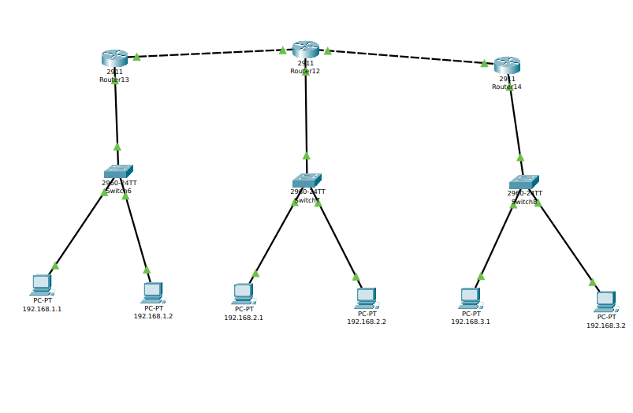
Topology 3:
Router topology for connecting 4 computers over a single network.
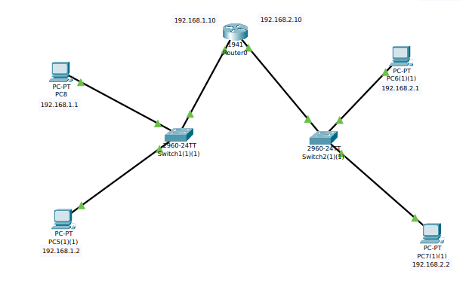

END

